1. Barley Delight (Yava Ksheera) :
Ref :
- Charaka Chikitsasthana 11/19
- ICMR – National Institute of Nutrition (NIN). Dietary Guidelines for Indians, 2024.

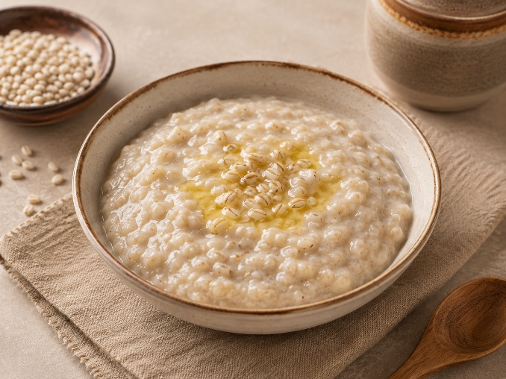
Image created with the use of AI

Ingredients :
Cow’s milk – 200 ml (as needed)
Barley – 30 gm (2tablespoon)
Cow’s ghee – 5 gm (1 teaspoon)

Method of preparation :
- Mix barley flour with a little milk to form a smooth paste.
- Add the remaining milk and cook over a low flame with continuous stirring until the barley is fully cooked.
Add cow’s ghee, mix well and serve warm

2. Blackgram Porridge(Vrushya yavagu):
Ref :
- Charak Sutra 2/32
- ICMR – National Institute of Nutrition (NIN). Dietary Guidelines for Indians, 2024.

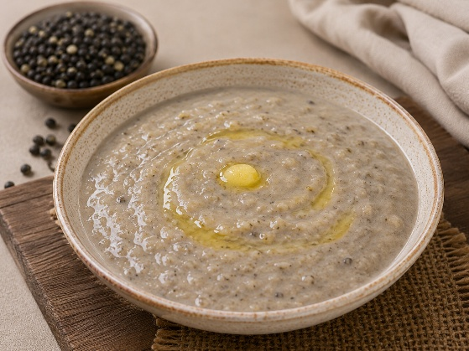
Image created with the use of AI

Ingredients :
Split black gram – 30gm (3/4 cup)
Ghee – 10-15 ml(2-3 teaspoon)
Milk – 180 ml (as needed)

Method of preparation:
- Take one part of split black gram wash thoroughly.
- Take vessel with 6 parts of milk, heat it on medium flame add 1 part of split black gram in to the boiling milk.
- Boil it properly if it needs more milk for proper boil then add it accordingly.
- After it is fully boiled and attains the semisolid consistency then add 2 -3tsp. of ghee to it, mix it well then have it.

3. Shrikandha (Rasala)
Ref :
- Shri Ksema Sarmakrut Ksemakutuhalam Classical Treatise on health care, Dietetics and Cookery – Culinary Science (Sanskrit Text with English Commentary) By Prof.(Dr.Gyanendra Pandey)
- ICMR – National Institute of Nutrition (NIN). Dietary Guidelines for Indians, 2024.

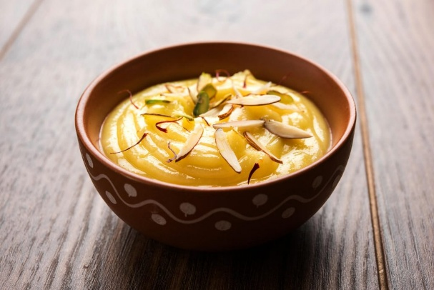
Credit:shrikhand-recipe-1024x684.jpg (1024×684)
Ingredients :
Curd – 50 gm (1/4cup)
Ginger powder – 2-3 gm (1/4tsp)
Rock sugar powder – to taste
Cardamom powder – 3 gm (½ tsp)
Cinnamon powder – 2 gm (¼ tsp)
Saffron (choice) – 2 strands
Method of preparation :
- Take fresh curd and tie it in a muslin cloth. Hang it for 4-6hrs or overnight to remove all the water.
- Then transfer the thick hung curd to a mixing bowl. Add rock sugar powder to taste, cardamom powder, cinnamon powder, ginger powder and if you want to use saffron then soak it in little quantity of milk then add it to the mixture.
- Now mix all together properly. If you want to add dry fruits then garnish with chopped almonds and pistachios
- Now you can have it.

4. Amla Blend (Amalaka Phala):
Ref :
- Shri Ksema Sarmakrut Ksemakutuhalam Classical Treatise on health care, Dietetics and Cookery – Culinary Science (Sanskrit Text with English Commentary) By Prof.(Dr.Gyanendra Pandey) 8/6
- ICMR – National Institute of Nutrition (NIN). Dietary Guidelines for Indians, 2024.

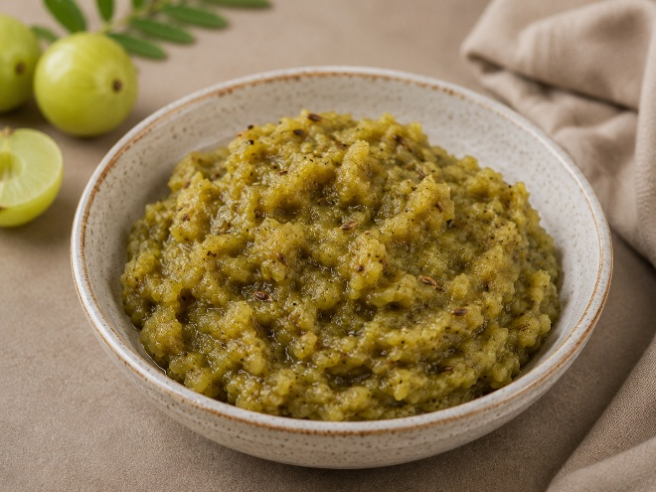
Image created with the use of AI
Ingredients :
Amla phala (Indian gooseberry) – 100 gm (1/2 cup)
Ghee – 10 gm (2 teaspoon)
Jeera – 5 gm (1 teaspoon)
Saindhava – to taste
Hingu – 0.1 gm (one pinch)

Method of preparation :
- Wash the Amla fruits thoroughly, place them in a steamer and steam for 10-15min until the amla fruits become soft and allow them to cool
- Remove the seeds and crush it properly by hand.
- Take a pan add 3-4tsp.of ghee, wait till the ghee becomes hot
- Then add 1/4tsp. jeera allow them to crackle and add hingu to it after that add cooked and crushed amla paste to it fry it properly until it cooked properly
- Lastly add Saindhava lavana / rock salt to it as quantity required and mix it well.

5. Creamy eggplant delight (Brinjal Preparation):

Ref :
- Shri Ksema Sarmakrut Ksemakutuhalam Classical Treatise on health care, Dietetics and Cookery – Culinary Science (Sanskrit Text with English Commentary) By Prof.(Dr.Gyanendra Pandey)
8/26
- ICMR – National Institute of Nutrition (NIN). Dietary Guidelines for Indians, 2024.

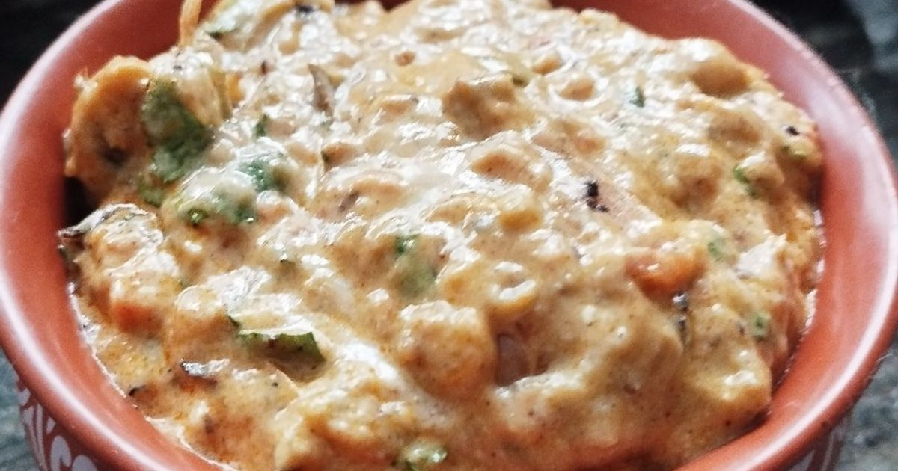
Credit: https://img-global.cpcdn.com/recipes/7f6eed9d7145d893/1200x630cq80/photo.jpg
Ingredients :
Brinjal – 130-150 gm (3/4 cup)
Ghee – 10-15 gm (3-4 teaspoon)
Mustard seeds – 2-3 gm (1/2 teaspoon)
Jeera – 2-3 gm (1/2 teaspoon)
Rock salt – to taste
Yoghurt – 100 gm (1/2 cup)

Total quantity – 200-210 gm

Method of preparation :
- Wash the brinjal thoroughly, place them in a steamer and steam for 10-15min. until the brinjal becomes soft and well-cooked then allow them to cool
- Remove the stalk, pound the mixture thoroughly until it becomes smooth or mash thoroughly using a masher until a smooth consistency is obtained.
- Take a pan add ghee and wait until the ghee becomes hot, add mustard seeds and jeera allow them to crackle, now add mashed brinjal, mix it well switch off the flame, allow it to cool.
- Add Yoghurt and rock salt as per the taste mix it well, duly covered up to 3-5min. and served.

6. Sesame chutney :

Ref :Traditional food recipes from Ayush systems of medicine
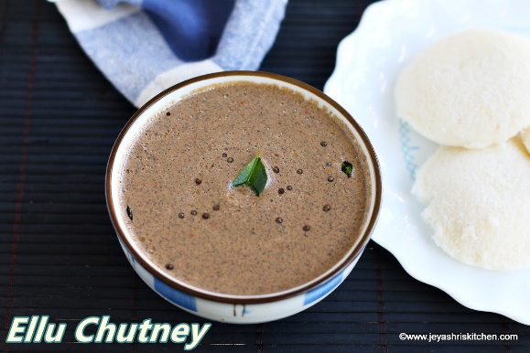
Credit:https://blogger.googleusercontent.com/img/b/R29vZ2xl/AVvXsEjffHrGozhDhenmljCNlFwCjLfiq6KxGcsdVzgJOGwzUmgiboJ03TKANsBxOcyhGoqvEVts1pFa8fTAoK4UzKyax12067U0XRtmfs7_Y_WgnwSnGLk1EM-L2rkfo1t5GDLRjCZ_eU7LVWDm/w1200

Ingredients :
Black sesame – 50-54 gm (1/4 cup)
Coriander leaves – 40 gm (1/4 cup)
Garlic – 6 cloves
Black pepper powder – 2 gm (1/4 teaspoon)
Lemon juice – 75 ml (5 tablespoon)
Cumin seeds – 3 gm (1/2 tsp)
Peanut – 18 gm (3-4 teaspoon)
Rock salt – to taste
Rock sugar – 5 gm (1 teaspoon)
Water – 20-30 ml (as needed)

Total quantity : 240-242 gm.

Method of preparation :
- Take a pan dry roast the groundnuts until it turns to lightly golden colour on medium flame.
- Once roasted, set it aside and allow it to cool.
- Dry roast the sesame seeds on low flame, do not over heat or burn it.
- All the above mentioned ingredients are taken in mixer grinder along with roasted ground nut and sesame seeds, 6 garlic cloves, pepper powder, cumin seeds coriander leaves, rock sugar, rock salt as per the taste
- Grind it into smooth paste by adding required amount of water to it to obtain the desired chutney consistency.
- Once the smooth paste is obtain then add lemon juice to it and mix it well then have it with any of the dishes of your choice.

7. Green chutney :

Ref :Traditional food recipes from Ayush systems of medicine

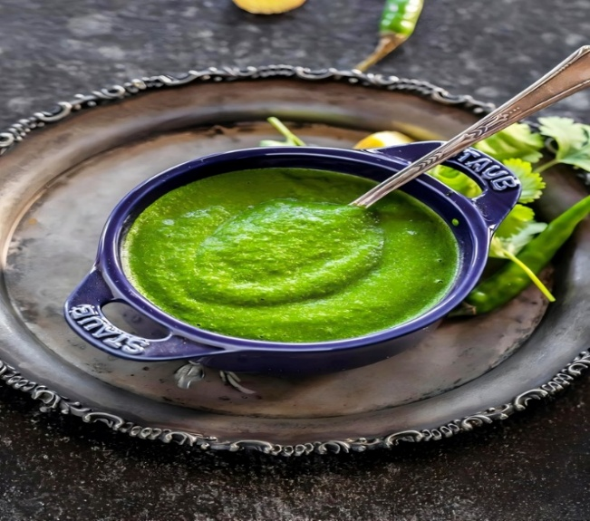
Credit:https://industhanfood.ie/wp-content/uploads/2024/08/Green-Chutney-1.jpg

Ingredients :
Drumstick leaves/Fenugreek leaves/Palak – 30-50 gm
Peanut/Bengal gram/Black gram – 10-12 gm (2-3 teaspoon)
Grated coconut – 15-20 gm (3-4 teaspoon)
Fenugreek seeds – 2-3 gm (1/2 teaspoon)
Cumin seeds – 2-3gm (1/2 teaspoon)
Coriander seeds – 2-3 gm (1/2 teaspoon)
Cloves – 2-3
Black pepper powder – 2-3 gm (1/4 teaspoon)
Hingu – 1-2 gm (one pinch)
Chopped tomato – 15-20 gm (3-4 teaspoon)
Lemon juice / tamarind – 5-10 ml (to taste)
Rock salt – 2-3 gm (to taste)
Jaggery – 1-2 gm (to taste)
Curd – 15-20 gm (3-4 teaspoon)
Water – 10-15 ml (as needed)

Total quantity : ½ medium size bowl

Method of preparation :
- Take a pan heat it on medium flame, add Peanut/Bengal gram/Black gram and fenugreek seeds dry roast it well and set it aside. Then add cumin seeds, coriander seeds, cloves dry roast it and leave it cool down.
- Take a mixer jar, add roasted ingredients and grated coconut grind along with required quantity of water / curd blend up to a smooth paste.
- After that add remaining ingredients to jar i.e. 1 cup of green leaves as your choice and add chopped tomato, black pepper, rock salt, jaggery, tamarind as per taste.
- And blend it all together up to it becomes smooth paste.
- Seasoning may be done for enhancing the taste with oil, mustard seeds, curry leaves and dry red chillies.

8. Date and Tamarind chutney : P. No : 207

Ref : Gowans S. Food for Life: Ayurvedic Recipes. Chennai: Shanti Gowans; 2009. p. 52.

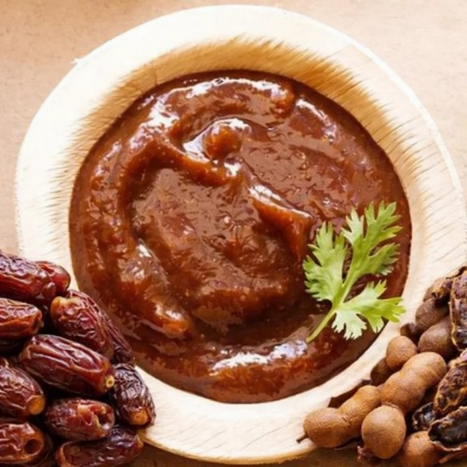
Credit:https://5.imimg.com/data5/SELLER/Default/2026/2/582214469/GA/ZB/AS/200402654/50495268-e852-4278-81dd-9942bc998a22-1000x1000.png
Ingredients :
Tamarind paste – 80 gm (½ cup)
Dates (pitted) – 40 gm (1/4 cup)
Brown sugar – 25 gm (to taste)
Cumin powder – 5 gm (1 teaspoon)
Rock salt – to taste

Total quantity : 145-150 gm (3/4 medium size cup)

Method of preparation :
- Take a pan add tamarind paste, pitted dates, Brown sugar, cumin powder and rock salt as per the taste mix it all together and cook well.
- Serve with plain rice.

9. Golden Grain Halwa(Lalita) :
Ref:
- Shri Ksema Sarmakrut Ksemakutuhalam Classical Treatise on health care, Dietetics and Cookery – Culinary Science (Sanskrit Text with English Commentary) By Prof.(Dr.Gyanendra Pandey) 10/88
- ICMR – National Institute of Nutrition (NIN). Dietary Guidelines for Indians, 2024

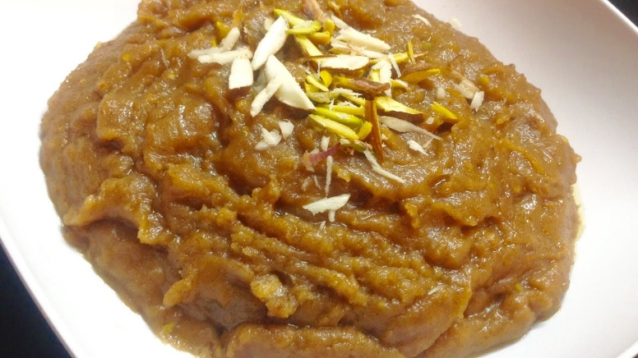
Credit: https://i.ytimg.com/vi/X5coOUw8rQs/maxresdefault.jpg

Ingredients :
Wheat flour – 25-30 gm (1/4 cup)
Ghee – 15-20 gm (3-4 teaspoon)
Rock sugar powder – 20-30 gm (to taste)
Priyala (Chironji) – 5 – 10 gm (2 teaspoon)
Coarse powder of dry fruits – 5-10 gm (2 teaspoon)
Milk – 90-100 ml (½ cup)
Aromatic powder – 2-3 gm (1/2 teaspoon)
(Cardamom – 3-4, Clove – 2-3, Pepper – 2-3, Cinnamon – 2-3inch, Dry ginger – 2-3 inch, Edible camphor (pacha karpooram) – 2-3 small crystals – make all them into fine powder)

Total quantity: 100-150 gm (3/4 medium size cup)

Method of preparation :
- Take ghee in a pan once the ghee becomes hot roast a coarse powder of dry fruits and chironji until they turn golden colour.
- Take ghee in a pan and once the ghee become hot add wheat flour and roast it well in a medium flame
- Add sugar powder as required quantity along with roasted dry fruits and chironji cook further by adding milk, stir continuously to prevent lumps from forming.
- Also add ghee in adequate amount if required.
- Continue cooking and stirring until the mixture avoids sticking with laddle and reaches a smooth halwa like consistency, then add aromatic powder and mix it well.

Contraindications:
- Diabetes
- Overweight / Obesity
- Lactose intolerance
- Sedentary life style with poor metabolism

10. Ash gourd Treat (Khanda Kusmanda) :

Ref :

- Shri Ksema Sarmakrut Ksemakutuhalam Classical Treatise on health care, Dietetics and Cookery – Culinary Science (Sanskrit Text with English Commentary) By Prof.(Dr.Gyanendra Pandey) 8/53
- ICMR – National Institute of Nutrition (NIN). Dietary Guidelines for Indians, 2024

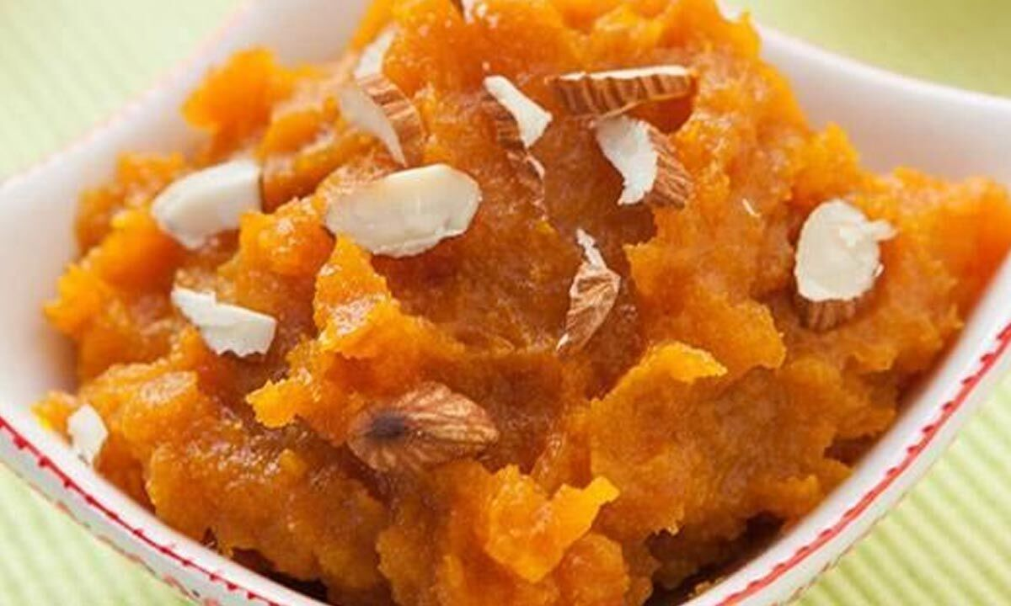
Credit:https://assets.thehansindia.com/h-upload/2022/09/14/1312314-pumpkin-halwa.jpg

Ingredients :
Chopped ash gourd – 80-100 gm (1/2 cup)
Milk – 100-120 ml (as needed)
Ghee – 20-30 gm (as needed)
Rock sugar powder – 30-40 gm (to taste)
Dry fruits (Choice) – 10-15 gm (1 tablespoon)
Aromatic powder – 2-3 gm (1/2 teaspoon)
(Cardamom – 3-4, Clove – 2-3, Pepper – 2-3, Cinnamon – 2-3inch, Dry ginger – 2-3 inch, Edible camphor (pacha karpooram) – 2-3 small crystals – make all them into fine powder)

Total quantity : 150-180 gm (1 medium size cup)

Method of preparation :
- Take chopped ash gourd, place them in a steamer and steam for 15-20min. until the ash gourd pieces become soft.
- Take another pan with milk add steamed ash gourd pieces and cook on medium flame and stirring occasionally until the pieces become soft and the milk is absorbed
- Mash these boiled pumpkin pieces thoroughly using a masher until a smooth consistency is obtained.
- Add more milk as needed during cooking to facilitate proper boiling and obtain the desired consistency.
- Take another pan with ghee heat it properly and add smashed pumpkin to it saute it properly for 8-10min. until the raw smell disappears.
- Add sugar as per required taste, mix it properly
- Continue cooking until the mixture becomes halwa like consistency.
- After that add chopped, ghee roasted dry fruits and aromatic powder to it and mix well. Cook for another 2-3min. and switch off the flame. Serve hot / warm.

Contraindications:
- Diabetes
- Overweight / Obesity
- Lactose intolerance
- Sedentary life style with poor metabolism

11. Coconut Delight (Narikera ksheeri):

Ref :
- Bhojana Kutuhala Siddhannaprakarana (Ksheeri), p.44
- ICMR – National Institute of Nutrition (NIN). Dietary Guidelines for Indians, 2024

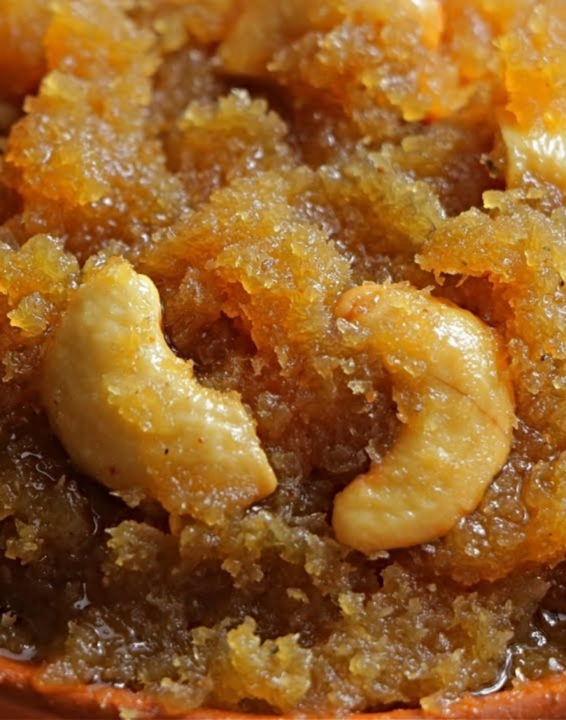
Credit:https://vismaifood.com/storage/app/uploads/public/0cc/628/b07/thumb__700_0_0_0_auto.jpg

Ingredients :
Fresh grated coconut – 50 gm ( ¼ cup)
Cow’s milk – 100 ml (as needed)
Rock sugar powder – 20 gm (to taste)
Cow’s ghee – 10 gm (2 teaspoon)
Aromatic powder – 2-3 gm (½ teaspoon)
(Cardamom – 3-4, Clove – 2-3, Pepper – 2-3, Cinnamon – 2-3inch, Dry ginger – 2-3 inch, Edible camphor (pacha karpooram) – 2-3 small crystals – make all them into fine powder)

Method of preparation :
- Take a fresh grated coconut in a mixture without adding much water. The mixture should remain slightly coarse and should not become too smooth.
- Take a vessel add cow’s milk bring it to a gentle boil then add mixture coarse coconut to it and cook on medium flame and stir it continuously.
- Cook for 5-8min. until it reaches a mildly thick consistency. After that add rock sugar as per the required taste stir it well until completely dissolved.
- Then add cow’s ghee to it and aromatic powder (optional) mix it well for 1min. switch off the flame and garnish with dry fruits. Serve hot / warm.

Contraindications:
- Diabetes
- Overweight / Obesity
- Lactose intolerance
- Sedentary life style with poor metabolism

12. Royal Dessert (Lapsika):
Ref :
- Bhojana Kutuhala Siddhannaprakarana (Bhaksha prakarana), p.44
- ICMR – National Institute of Nutrition (NIN). Dietary Guidelines for Indians, 2024.

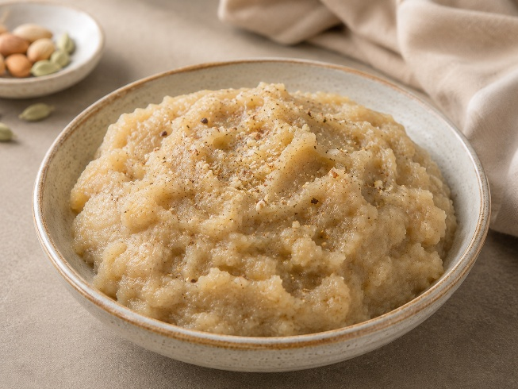
Image created with the use of AI

Ingredients :
Refined wheat flour – 30 gm (1/8 cup)
Ghee – 15 gm (1 tablespoon)
Milk – 90-100 ml (1/2 cup)
Aromatic powder – 2-3 gm (1/2 teaspoon)
(Cardamom – 3-4, Clove – 2-3, Pepper – 2-3, Cinnamon – 2-3inch, Dry ginger – 2-3 inch, Edible camphor (pacha karpooram) – 2-3 small crystals – make all them into fine powder.)

Method of Preparation :
- Take a ghee in a pan and heat it on low flame and add refined wheat flour to it and roast it well on medium flame.
- Add cup of milk and sugar as per the desired quantity and stir continuously until this mixture solidifies.
- Add aromatic powder to it and mix well. Then have it.

Contraindications:
- Diabetes
- Overweight / Obesity
- Lactose intolerance
- Sedentary life style with poor metabolism

13. A Breakfast Rice :

Ref : Morningstar A. Ayurvedic Cooking for All: Familiar Food Prepared with Ayurvedic Principles. 3rd reprint. New Delhi: Motilal Banarsidass Publishers Pvt. Ltd.; 2011. p. 44.

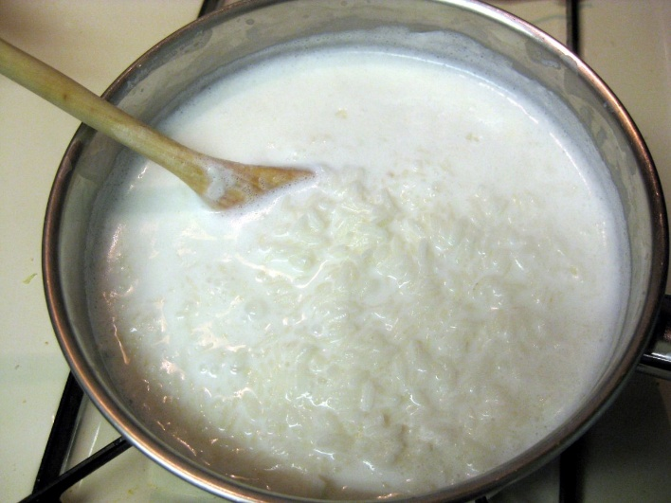
Credit:https://in.images.search.yahoo.com/search/images

Ingredients :
Cooked Rice – 100-120 gm (1/2 cup)
Cow milk – 120-140 ml (3/4 cup)
Dry Coriander powder –2-3 gm (1/2 teaspoon)
Cardamom powder – 2-3 gm (1/2 teaspoon)
Ghee – 5-10 gm (2 teaspoon)

Total quantity: one medium size bowl

Method of preparation :
- Take a pan add milk and heat it on medium flame
- Once the milk starts to boil then add softly cooked rice, coriander powder, cardamom powder and ghee to it
- And simmer it for 5 min.
- Now you can have it.
- If you want to have it as a smoother texture then add this to the blender and blend it smoothly and also add honey if you want as required quantity.

14. Rice Almond Breakfast Cereal :

Ref : Morningstar A. Ayurvedic Cooking for All: Familiar Food Prepared with Ayurvedic Principles. 3rd reprint. New Delhi: Motilal Banarsidass Publishers Pvt. Ltd.; 2011. p. 44

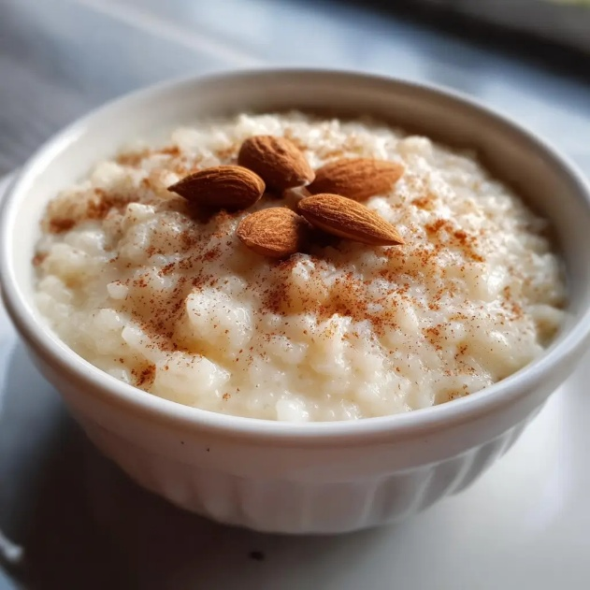

Credit:https://in.images.search.yahoo.com/search/images

Ingredients :

Uncooked Rice – 50 gm (1/4 cup)
Raw Almonds – 45 gm (3 tablespoon)
Rock salt – to taste
Ghee – 3-5 ml (1 teaspoon)
Rock sugar – 15-20 gm (to taste)

Total quantity : 1 medium size bowl

Method of preparation :
- Soak Almonds overnight
- Take overnight soaked Almonds into the grinder and make it as fine powder / fine paste.
- Clean grinder add uncooked rice and grind it until it turns into fine powder.
- Take 3 cups of water in the pan and bring it to boil then add a pinch of rock salt to it.
- Then reduce the heat to medium flame, After that add grinded powder of rice and almond to it with continue stirring to prevent lump forming.
- Continue cooking about 5 min. or until it properly done.
- Then add 2tsp. of ghee and Rock sugar powder to it as per the taste and mix it well. Then have it.

15. Rice pudding :

Ref : Gowans S. Food for Life: Ayurvedic Recipes. Chennai: Shanti Gowans; 2009. p. 147

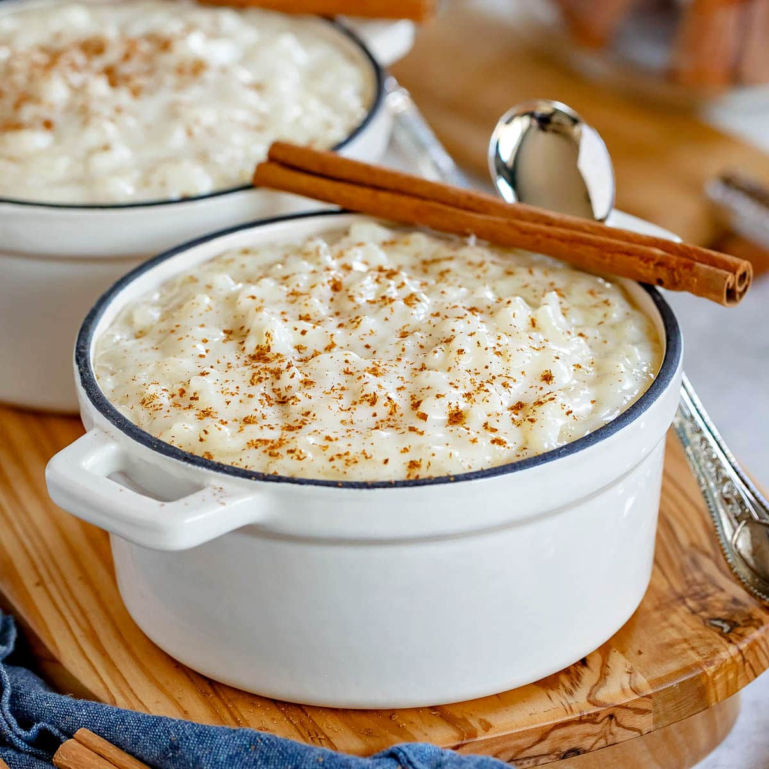
Credit:https://www.momontimeout.com/wp- content/uploads/2021/08/rice-pudding-square.jpeg

Ingredients :
Rice – 50 gm (1/4 cup)
Dates – 6
Cinnamon powder – 1-2 gm ( ¼ teaspoon)
Ginger paste – 4-5 gm (1 teaspoon)
Saffron – 2-3 strands
Milk – 120-150 ml (as needed)

Total quantity: one medium size bowl

Method of preparation :
- Take a vessel or cooker cook all the ingredients together with proper quantity of water.
- If you want more creamier then add required quantity of milk / water. And have it.

16. Rice and date pudding :
Ref : Gowans S. Food for Life: Ayurvedic Recipes. Chennai: Shanti Gowans; 2009. p. 235.

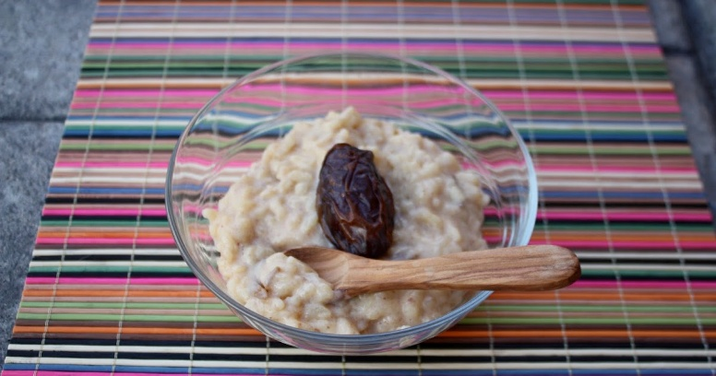
Credit:https://blogger.googleusercontent.com/img
Ingredients :
Cooked rice –40-50 gm (1/2 cup)
Milk – 140-150 ml (as needed)
Dates – 10 chopped

Total quantity : 210 gm

Method of preparation :
- Boil milk in a pan, add chopped dates and stir the mixture until milk turns into brown colour
- Add cooked rice to it and simmer until the mixture thickens, for that if it needs more milk then add it accordingly
- Once it reaches to the creamy thickness then switch off the flame and have it.

